**CHAPTER 1**

**INTRODUCTION**

The project titled “**Grocery Database Management System**” is library management software for monitoring and controlling the transaction in a shop. This project is developed in C# and .NET CORE which focuses on basic operation of a library like insertion of a customer, new product, searching product, updating Seller, Department, etc and facility to buy items from the shop.

This project is a **Windows Form Application** designed and developed to help users maintain and organize the Grocery Store. Our software is easy to use and it features a familiar and well thought out, an attractive user interface, combined with strong **searching, updating, insertion and deletion**.

The best way of utilization of all its amenities is possible only if we have an efficient system to manage its functions. Our Grocery Database System is one such system that efficiently manages all the basic Grocery store tasks. Our System is an effective Grocery system which makes the producer and consumer to easily access the Products available and the staff who can handle the functions of the Seller and Department without any hindrance.

**Chapter 2**

**SYSTEM REQUIREMENT**

One of the most difficult tasks is that, the selection of the software, once system requirement is known is determining whether a software package fits the requirements. After initial selection further security is needed to determine the desirability of software compared with other candidates. This section first summarizes the application requirement question and then suggests more detailed comparisons.

**Hardware Requirement**

* 32/64-bit processor
* i3 or greater intel processor chip
* 800 or more MHz processor
* DirectX 9 capable graphics driver

**Software Requirement**

* Windows XP or higher version OS
* .NET Framework 3.0 or higher

**Chapter 3**

**System Design**

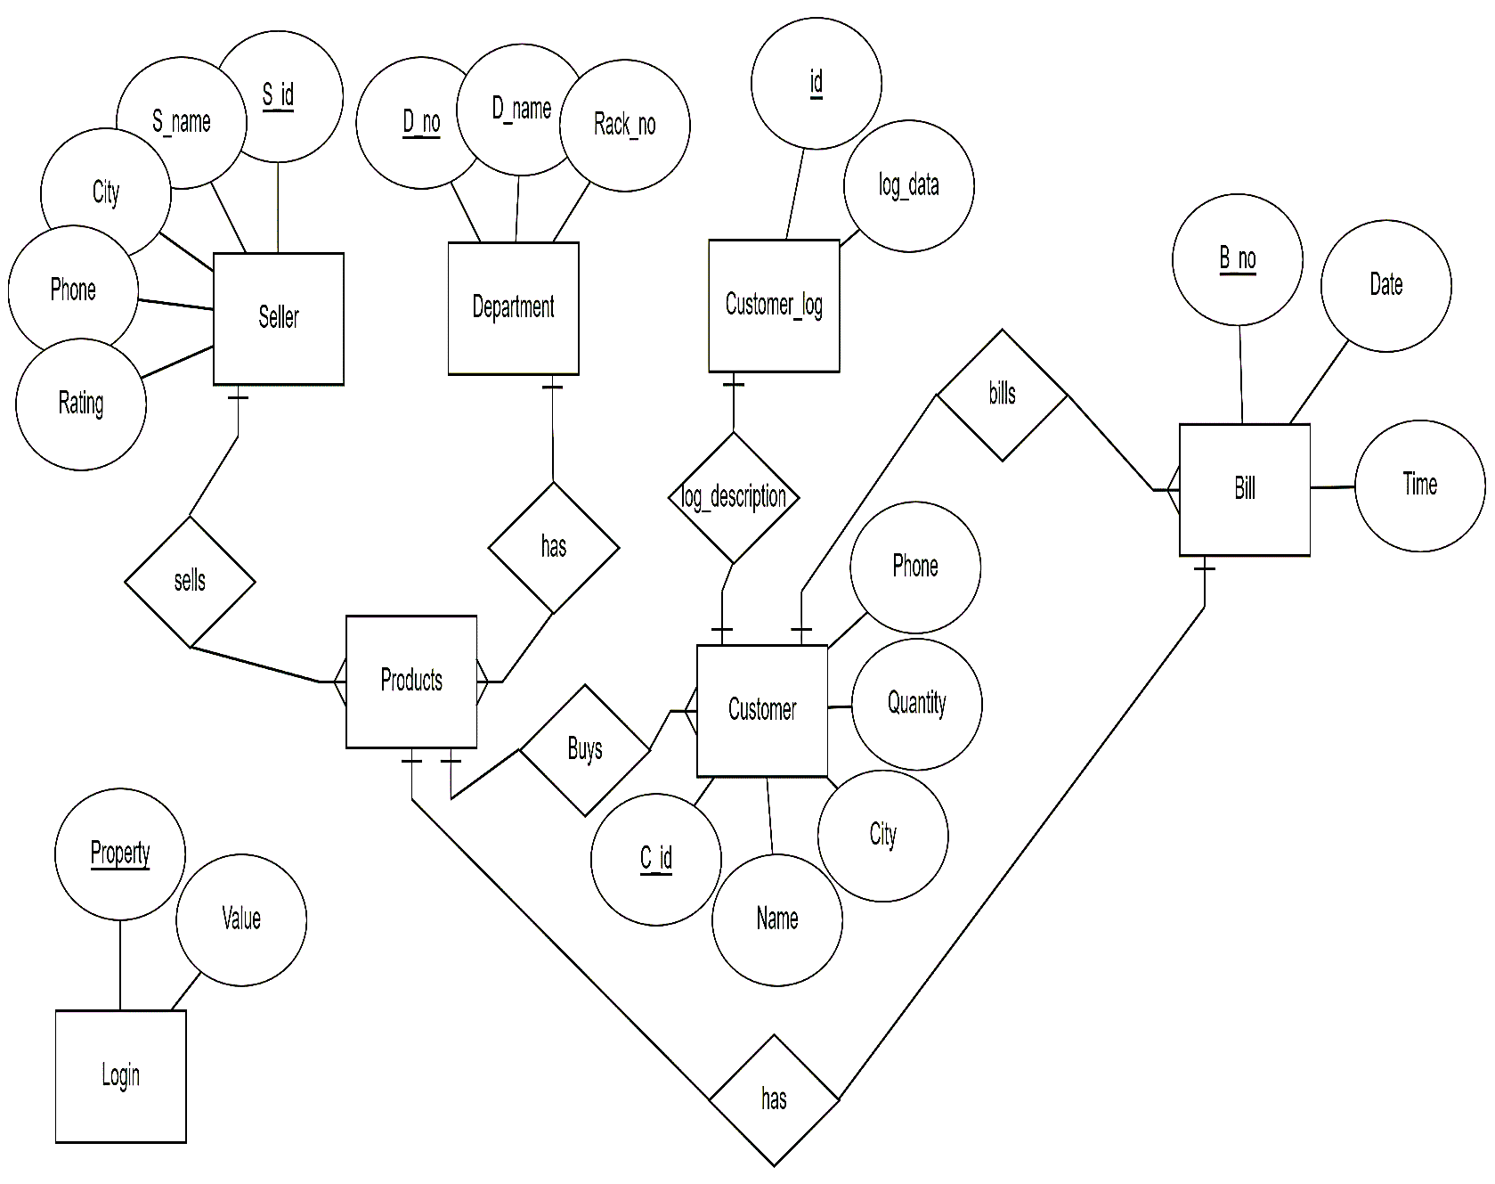3.1 **ER-Diagram**



Fig 3.1 **Entity Relationship Diagram for Grocery Data Management System**



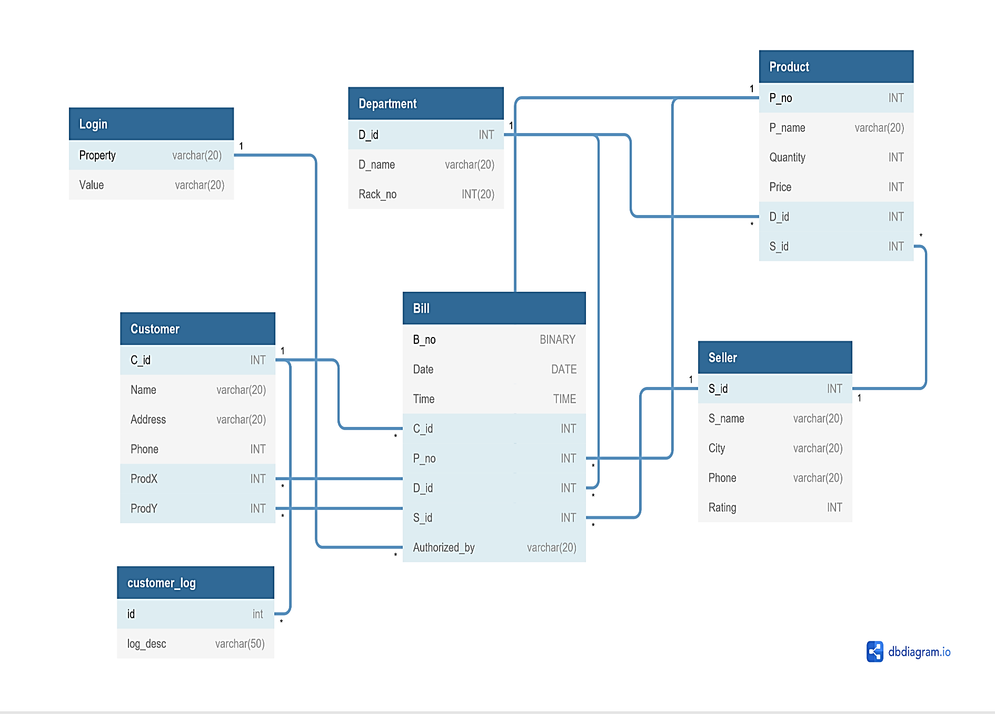3.2 **Schema** **Design**



Fig 3.2 **Schema Design of Grocery Data Management**

3.3 **Table** **Description**

3.3.1 **SELLER**

|  |  |  |  |
| --- | --- | --- | --- |
| **Column Name** | **Datatype** | **Constraint** | **Description** |
| S_id | integer | PRIMARY KEY | Unique ID of Seller |
| S_name | nchar(10) |  | Name of Seller |
| City | nchar(10) |  | City where the Seller resides |
| Phone | nchar(10) |  | Phone Number of the Seller |
| Rating | integer |  | Rating os Seller |

3.3.2 **DEPARTMENT**

|  |  |  |  |
| --- | --- | --- | --- |
| **Column Name** | **Datatype** | **Constraint** | **Description** |
| D_id | integer | PRIMARY KEY | Unique ID of Department |
| D_name | nchar(50) |  | Name of Department |
| Rack_Number | integer |  | Rack Number of each Department |

3.3.3 **PRODUCTS**

|  |  |  |  |
| --- | --- | --- | --- |
| **Column Name** | **Datatype** | **Constraint** | **Description** |
| P_no | integer | PRIMARY KEY | Unique ID of a Product |
| P_name | nchar(50) |  | Name of the product |
| Quantity | integer |  | Available Quantity in the store |
| Price | integer |  | Price of each Product (1kg/1pc) |
| S_id | integer | References S_id from Seller Table | Seller ID of the Product |
| D_id | integer | References D_id from Department Table | Department ID of the Product |

3.3.4 **CUSTOMER**

|  |  |  |  |
| --- | --- | --- | --- |
| **Column Name** | **Datatype** | **Constraint** | **Description** |
| C_id | integer | PRIMARY KEY | Customer ID |
| Name | nchar(10) |  | Name of Customer |
| City | nchar(10) |  | City where the Customer Resides |
| Phone | integer |  | Phone Number of Customer |
| **Column Name** | **Datatype** | **Constraint** | **Description** |
| P_no | integer | References P_no from Products Table | Product Number that the customer wants to buy from Shop. |
| Quanity | integer |  | Quantity of the product that the Customer wants to buy |

3.3.5 **Customer** **log** (**Trigger** **used**)

|  |  |  |  |
| --- | --- | --- | --- |
| **Column Name** | **Datatype** | **Constraint** | **Description** |
| id | integer | PRIMARY KEY | Log ID (Serial Number) |
| Log data | nchar(50) |  | Log of all Customers |

3.3.6 **Login**

|  |  |  |  |
| --- | --- | --- | --- |
| **Column Name** | **Datatype** | **Constraint** | **Description** |
| Property | nchar(20) | PRIMARY KEY | Username |
| Value | nchar(20) |  | Password |

3.3.7 **Bill**

|  |  |  |  |
| --- | --- | --- | --- |
| **Column Name** | **Datatype** | **Constraint** | **Description** |
| B_no | integer | PRIMARY KEY | Bill Number (auto generated) |
| Date | date |  | Current Date |
| Time | time |  | Current Time |
| C_id | integer | References C_id from Customer Table | Customer ID |

**Chapter 4**

**Problem Description**

4.1 **Login**

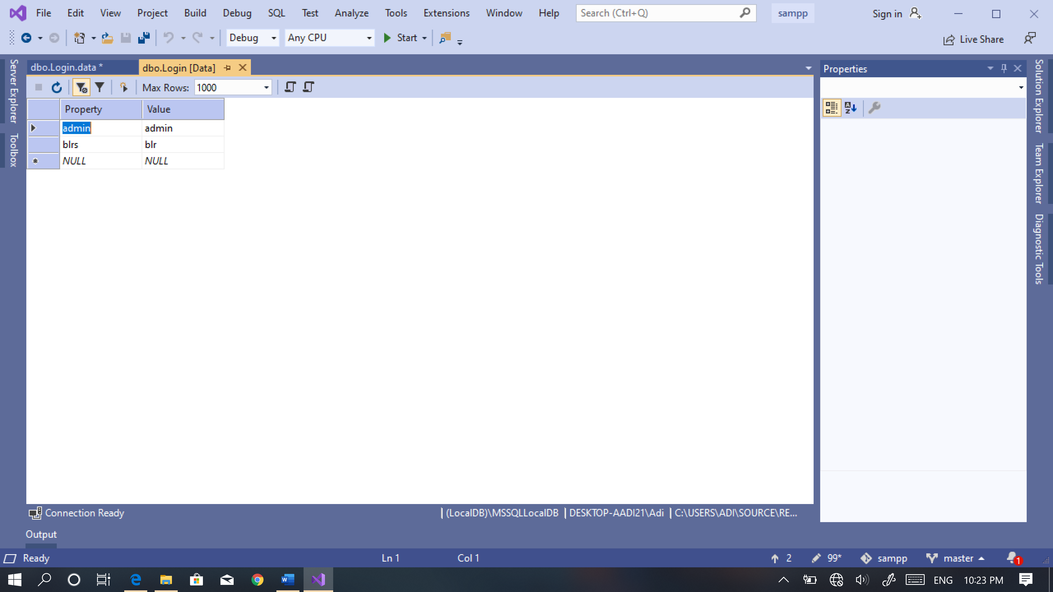

This **Login** table has 2 attributes with column name **Property** and **Value** which stores the **Username** and **Password** respectively. These are required for Login Credentials to the front end, as it provides security from unauthorized users. A new User can insert values into the Login table.

4.2 **Department**

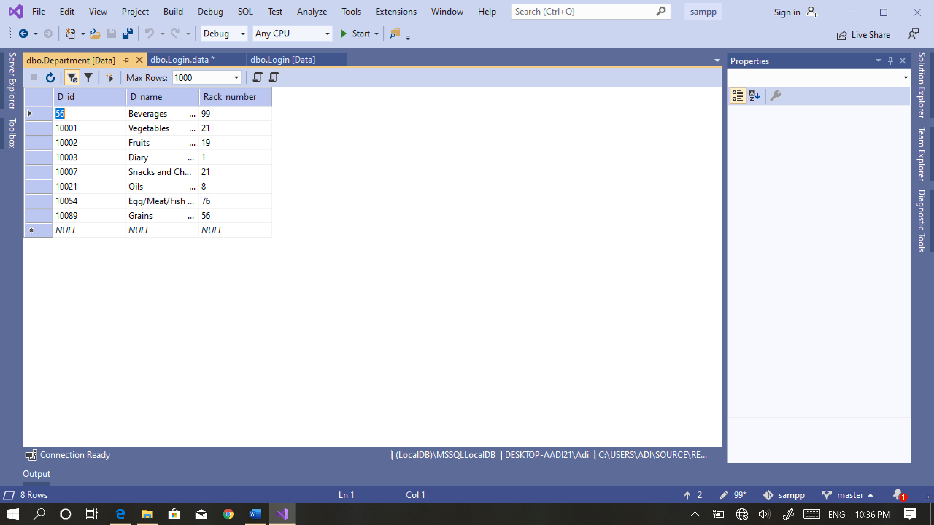

This **Department** table has 3 attributes with column name **D**_**id**, **D_name** and **Rack_number** which stores the Department **ID** with its respective **Name** and **Rack** **number** placed in. This table is required by Products table to choose each product with its respective department id. The user can **insert**, **delete** and **update** any record in the front end by entering appropriate values in the text boxes.

4.3 **Seller**

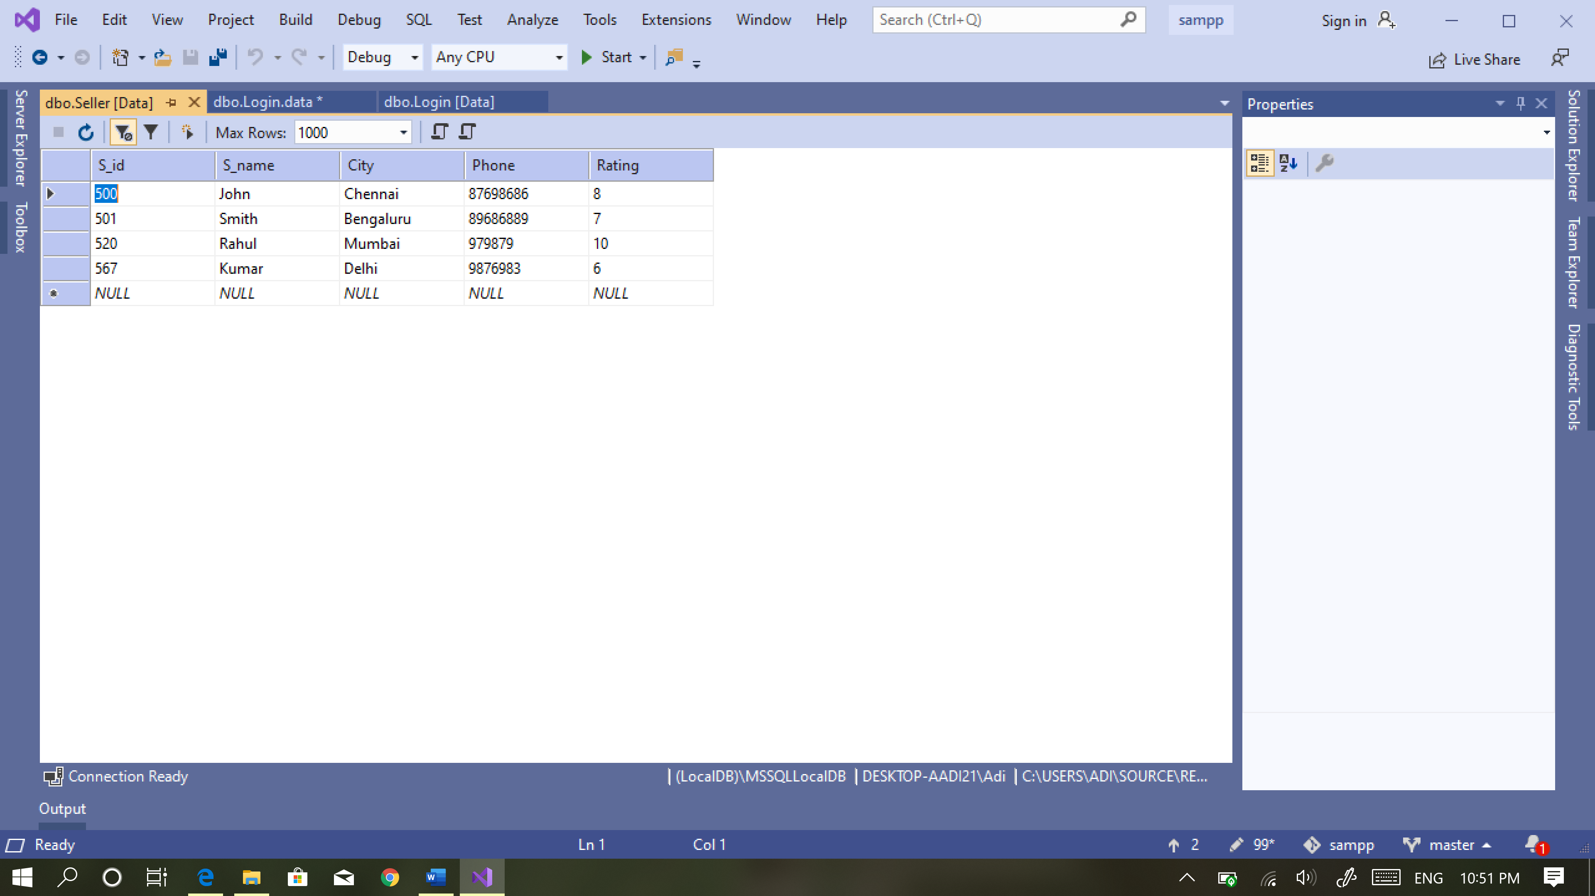

This **Seller** table has 5 attributes with column name **S**_**id**, **S_name**, **City**, **Phone**, **Rating** which stores the Seller **ID** with its respective **Name**, **City** **name**, **Phone** **Number** and **ratings**. This table is required by Products table to choose each product with its respective Seller id. The user can **insert** and **update** any record in the front end by entering appropriate values in the text boxes.

4.4 **Products**

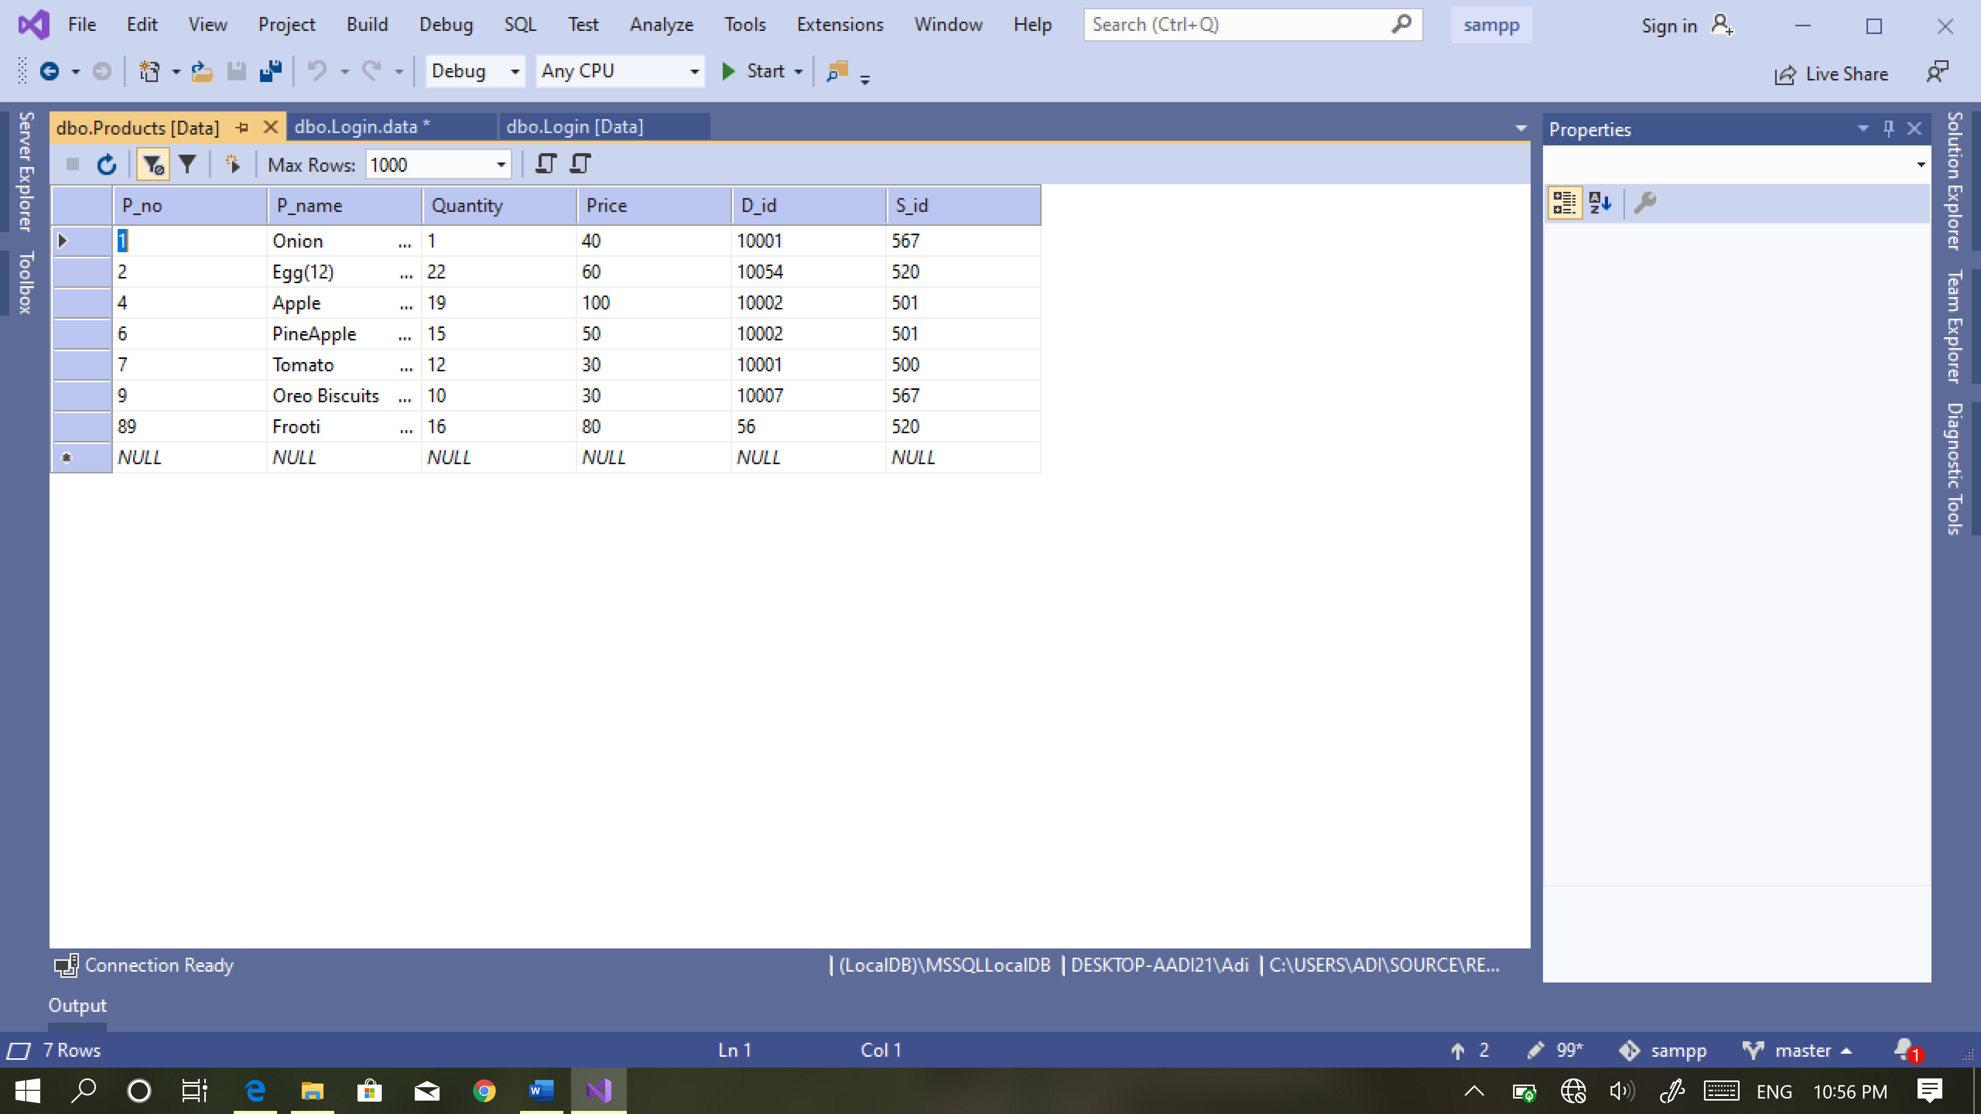

This **Products** table has 6 attributes with column name **P_no,** **P_name**, **Quantity**, **Price**, **D_id** and **S_id** which stores the Product **number** with its respective **Name**, **Quantity** available, **Price of each product**, respective **department id** and **seller id**. This table is required by **Customer** table by each customer to choose product with its respective Product number. The user can **insert, delete, search** and **update** any record in the front end by entering appropriate values in the text boxes.

4.5 **Customer**

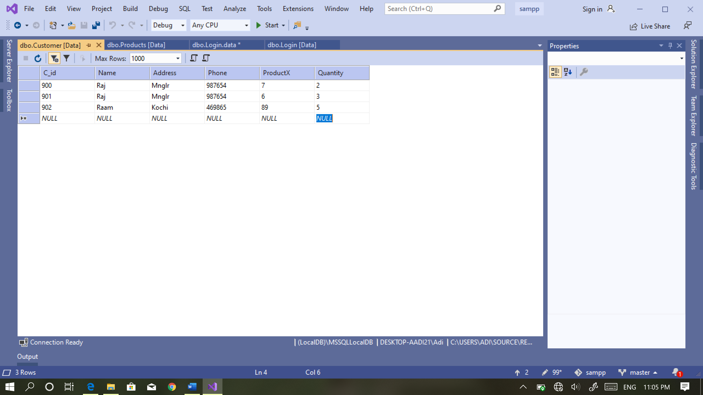

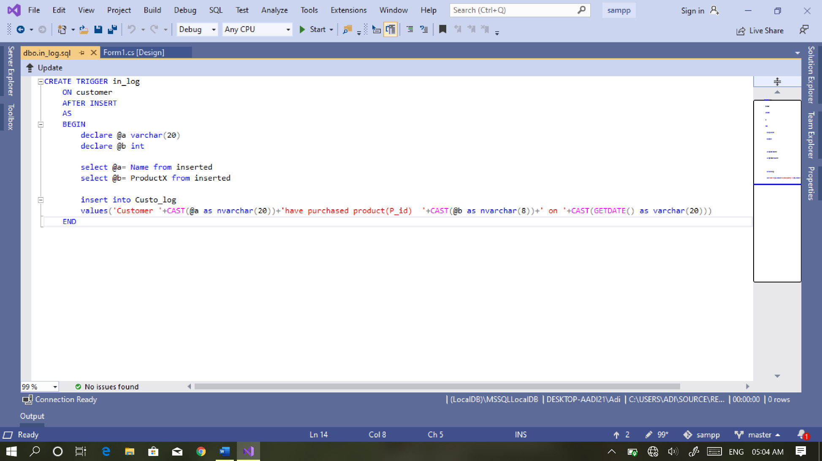This **Customer** table has 6 attributes with column name **C_id, Name, Address, Phone, ProductX, Quantity** which stores the Customer **ID** with its respective **Name**, **Address**, **Phone Number**, respective **Product number** and **Quantity**. This table is required by **Bill** table to generate bill with its respective Customer ID. The user can only **insert** any record in the front end by entering appropriate values when the customer purchases items.

This table has a **Trigger** such that **for every insert** of a row in the **customer** table there is an **insertion** in the **Customer** **log** table as well. This table is just used to keep a history of all transactions by the shop.

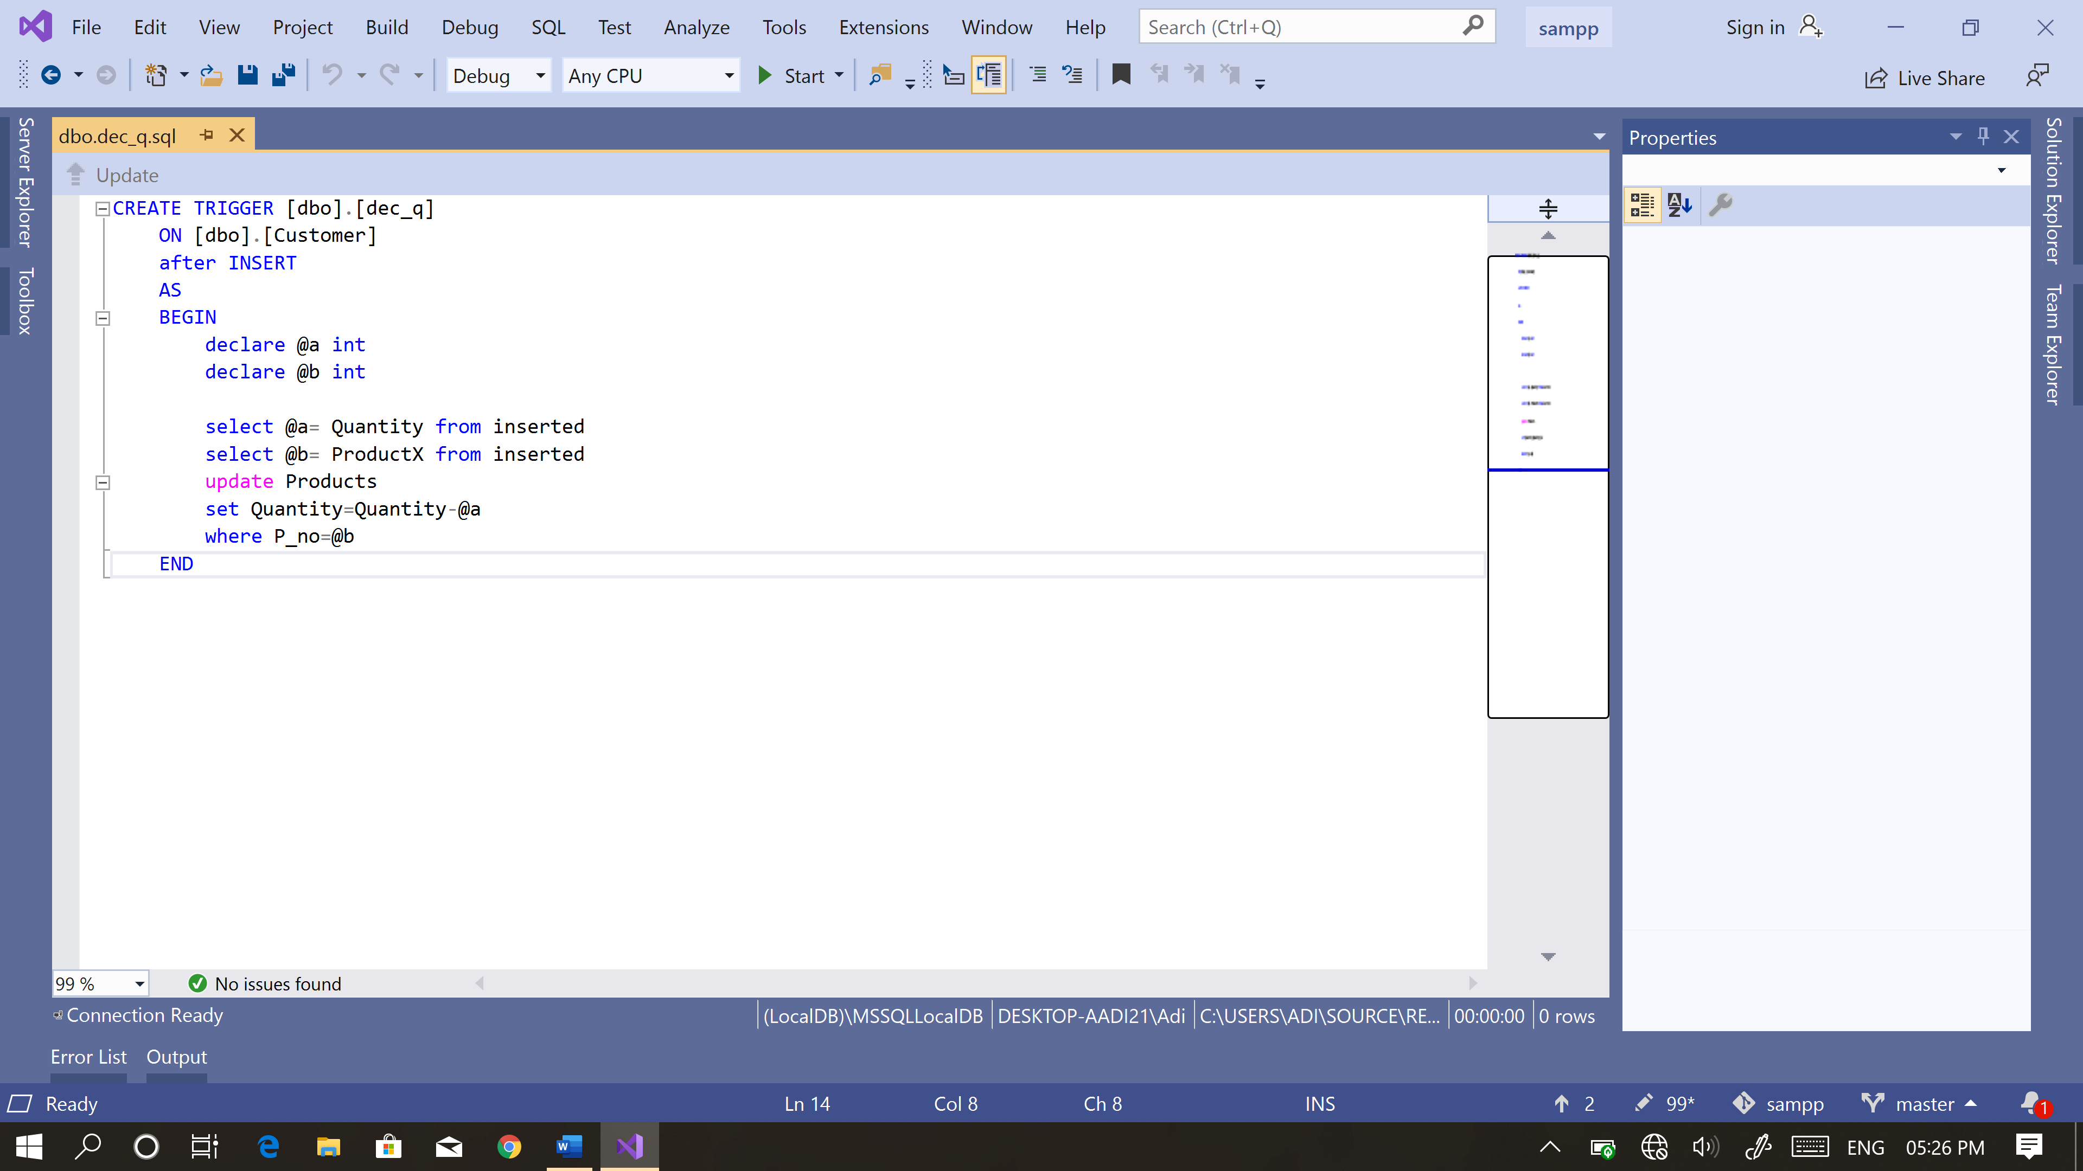

It also has another **Trigger** such that for **every insert** of a row in **customer** table there is **reduction** in the available **quanity** of the **Products** table by the Purchased quanity in the customer table w.r.t the **Product Number**.

4.6 **Customer_log**

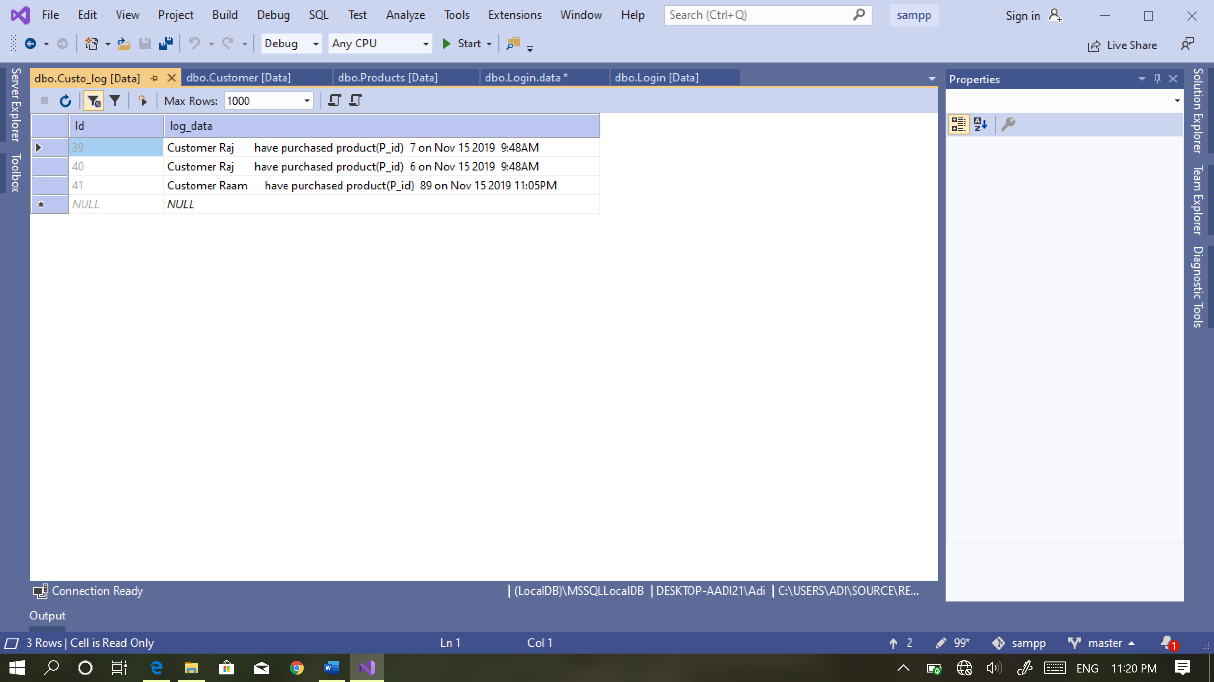

This **Custo_log** table has 2 attributes with column name **Id** and **log_data** which stores the **history** of all customer’s transactions with the statement. This table is created **automatically** when the **Trigger** is **fired** by the Customer table.

4.7 **Bill**

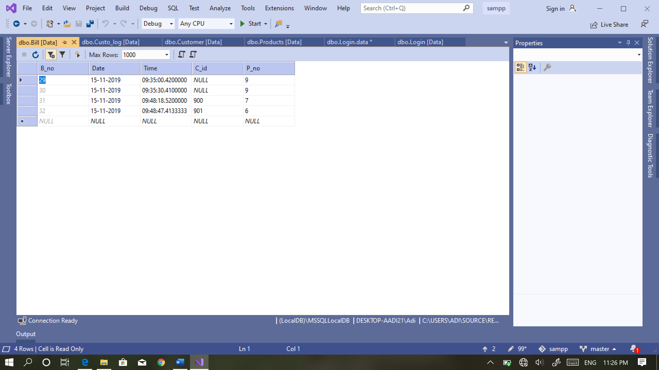

This **Bill** table has 5 attributes with column name **B_no**, Date**, Time, C_id** and **P_no** which stores the **Bill number** which is automatically generated by an identity increment 1 followed by **current Date** (dd-mm-yyyy), **current Time** (hh:mm:ss.sss), purchased **Customer’s ID** with their **product number**. This table is being inserted only when the customer purchases an item from the shop.

**Chapter 5**

**Implementation**

5.1 **Code for Products User Control**

public void refresh()

{

try

{

SqlCommand cmd = new SqlCommand("showee", con);

cmd.CommandType = CommandType.StoredProcedure;

SqlDataAdapter da = new SqlDataAdapter(cmd);

DataSet ds = new DataSet();

da.Fill(ds);

con.Open();

try

{

cmd.ExecuteNonQuery();

}

catch (Exception ex)

{

MessageBox.Show(" <<< INVALID SQL OPERATION! >>>\n" + ex);

}

con.Close();

dataGridView1.DataSource = ds.Tables[0];

this.dataGridView1.Columns[0].AutoSizeMode = DataGridViewAutoSizeColumnMode.Fill;

this.dataGridView1.Columns[1].AutoSizeMode = DataGridViewAutoSizeColumnMode.Fill;

this.dataGridView1.Columns[2].AutoSizeMode = DataGridViewAutoSizeColumnMode.Fill;

this.dataGridView1.Columns[3].AutoSizeMode = DataGridViewAutoSizeColumnMode.Fill;

this.dataGridView1.Columns[4].AutoSizeMode = DataGridViewAutoSizeColumnMode.Fill;

this.dataGridView1.Columns[5].AutoSizeMode = DataGridViewAutoSizeColumnMode.Fill;

catch (Exception ex)

{

MessageBox.Show("" + ex);

}

}

private void add_button1_Click(object sender, EventArgs e)

{

SqlCommand cmd = new SqlCommand("insert_prod", con);

cmd.CommandType = CommandType.StoredProcedure;

cmd.Parameters.AddWithValue("@a", textBox1.Text);

cmd.Parameters.AddWithValue("@b", textBox2.Text);

cmd.Parameters.AddWithValue("@c", textBox3.Text);

cmd.Parameters.AddWithValue("@d", textBox4.Text);

cmd.Parameters.AddWithValue("@e", textBox5.Text);

cmd.Parameters.AddWithValue("@f", textBox7.Text);

con.Open();

try

{

cmd.ExecuteNonQuery();

}

catch(Exception ex)

{

MessageBox.Show(" <<< INVALID SQL OPERATION! >>>\n" + ex);

}

con.Close();

refresh();

}

private void delete_button3_Click(object sender, EventArgs e)

{

try

{

SqlCommand cmd = new SqlCommand("dele", con);

cmd.CommandType = CommandType.StoredProcedure;

cmd.Parameters.AddWithValue("@a", textBox1.Text);

con.Open();

try

{

cmd.ExecuteNonQuery();

}

catch (Exception ex)

{

MessageBox.Show(" <<< INVALID SQL OPERATION! >>>\n" + ex);

}

con.Close();

refresh();

}

catch (Exception ex)

{

MessageBox.Show("" + ex);

}

}

private void update_button2_Click(object sender, EventArgs e)

{

SqlCommand cmd = new SqlCommand("updat", con);

cmd.CommandType = CommandType.StoredProcedure;

cmd.Parameters.AddWithValue("@a", textBox1.Text);

cmd.Parameters.AddWithValue("@b", textBox2.Text);

cmd.Parameters.AddWithValue("@c", textBox5.Text);

cmd.Parameters.AddWithValue("@d", textBox4.Text);

cmd.Parameters.AddWithValue("@e", textBox3.Text);

cmd.Parameters.AddWithValue("@f", textBox7.Text);

con.Open();

try

{

cmd.ExecuteNonQuery();

}

catch (Exception ex)

{

MessageBox.Show(" <<< INVALID SQL OPERATION! >>>\n" + ex);

}

con.Close();

refresh();

}

private void serchId_button6_Click(object sender, EventArgs e)

{

try

{

SqlCommand cmd = new SqlCommand("sear", con);

cmd.CommandType = CommandType.StoredProcedure;

cmd.Parameters.AddWithValue("@a", textBox6.Text);

SqlDataAdapter da = new SqlDataAdapter(cmd);

DataSet ds = new DataSet();

da.Fill(ds);

con.Open();

try

{

cmd.ExecuteNonQuery();

}

catch (Exception ex)

{

MessageBox.Show(" <<< INVALID SQL OPERATION! >>>\n" + ex);

}

con.Close();

dataGridView1.DataSource = ds.Tables[0];

this.dataGridView1.Columns[0].AutoSizeMode = DataGridViewAutoSizeColumnMode.Fill;

this.dataGridView1.Columns[1].AutoSizeMode = DataGridViewAutoSizeColumnMode.Fill;

this.dataGridView1.Columns[2].AutoSizeMode = DataGridViewAutoSizeColumnMode.Fill;

this.dataGridView1.Columns[3].AutoSizeMode = DataGridViewAutoSizeColumnMode.Fill;

this.dataGridView1.Columns[4].AutoSizeMode = DataGridViewAutoSizeColumnMode.Fill;

this.dataGridView1.Columns[5].AutoSizeMode = DataGridViewAutoSizeColumnMode.Fill;

}

catch (Exception ex)

{

MessageBox.Show("" + ex);

}

}

5.2 **Code for Customer User Control**

public void refresh() // displaying customer log data grid view

{

SqlCommand cmd = new SqlCommand("trig_disp", con);

cmd.CommandType = CommandType.StoredProcedure;

SqlDataAdapter da = new SqlDataAdapter(cmd);

DataSet ds = new DataSet();

da.Fill(ds);

con.Open();

try

{

cmd.ExecuteNonQuery();

}

catch (Exception ex)

{

MessageBox.Show(" <<< INVALID SQL OPERATION! >>>\n" + ex);

}

con.Close();

dataGridView1.DataSource = ds.Tables[0];

this.dataGridView1.Columns[0].AutoSizeMode = DataGridViewAutoSizeColumnMode.Fill;

this.dataGridView1.Columns[1].AutoSizeMode = DataGridViewAutoSizeColumnMode.Fill;

}

private void purchase_button1_Click(object sender, EventArgs e)

{

SqlCommand cmd = new SqlCommand("custo", con); //inserting values to customer table

cmd.CommandType = CommandType.StoredProcedure;

cmd.Parameters.AddWithValue("@a", textBox1.Text);

cmd.Parameters.AddWithValue("@b", textBox2.Text);

cmd.Parameters.AddWithValue("@c", textBox3.Text);

cmd.Parameters.AddWithValue("@d", textBox6.Text);

cmd.Parameters.AddWithValue("@e", textBox4.Text);

cmd.Parameters.AddWithValue("@f", textBox5.Text);

con.Open();

try

{

cmd.ExecuteNonQuery();

}

catch (Exception ex)

{

MessageBox.Show(" <<< INVALID SQL OPERATION! >>>\n" + ex);

}

con.Close();

cmd = new SqlCommand("trans", con); // inserting values to Bill Table

cmd.CommandType = CommandType.StoredProcedure;

cmd.Parameters.AddWithValue("@a", textBox1.Text);

cmd.Parameters.AddWithValue("@b", textBox4.Text);

con.Open();

try

{

cmd.ExecuteNonQuery();

}

catch (Exception ex)

{

MessageBox.Show(" <<< INVALID SQL OPERATION! >>>\n" + ex);

}

con.Close();

refresh();

}

5.3 **Displaying Bill Stored procedure**

CREATE PROCEDURE [dbo].bill

AS

SELECT

b.B_no,

b.Date,

b.Time,

c.Name,

p.P_name,

d.D_name,

s.S_name,

p.Price*c.[Quantity] as Price

from Customer c,Products p,Department d,Bill b,Seller s

where

b.C_id=c.C_id and

b.P_no=c.ProductX and

c.ProductX=p.P_no and

p.D_id=d.D_id and

s.S_id=p.S_id

order by B_no desc;

RETURN 0

**Chapter 6**

**Results and Screenshots**

6.1 **Login Page**:

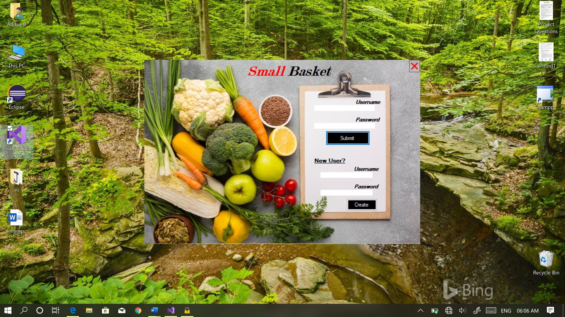

Fig 6.1 **Login Page**

This Application is secured with a username and password. In this page the user can either Login with their credentials else register into DB with their new username and password. After entering correct credentials, it will be redirected to the next form i.e. the Home page of the application.

6.2 **Department panel:**

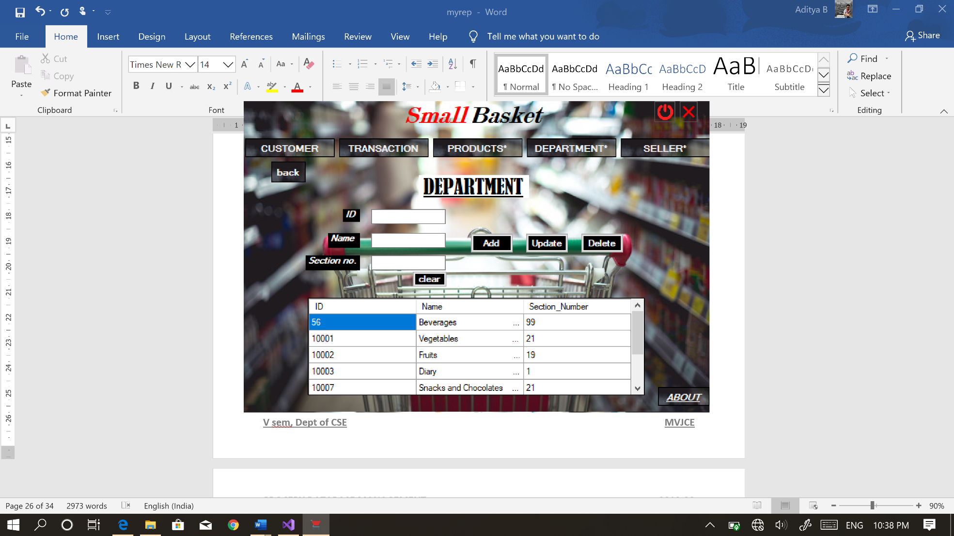

Fig 6.2 **Department Panel**

This panel consists of buttons to do certain tasks on the **Department** Table. It has 3 textboxes to enter value in its respective column of the table. **Add** button is used to insert values into the table. **Update** button used to make changes to the existing values in the table. **Delete** button is to delete the row by D_id. The **DataGrid** displays the Department Table.

6.3 **Seller panel:**

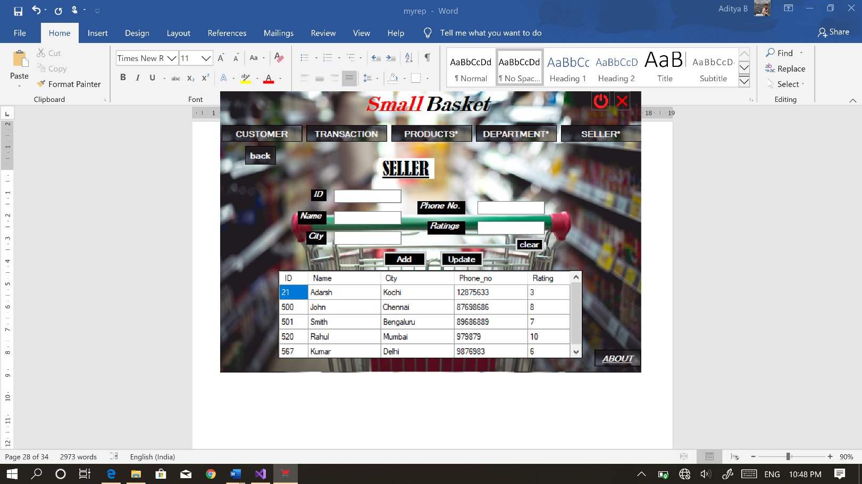

Fig 6.3 **Seller Panel**

This panel consists of buttons to do certain tasks on the **Seller** Table. It has 5 textboxes to enter value in its respective column of the table. **Add** button is used to insert values into the table. **Update** button used to make changes to the existing values in the table. The **DataGrid** displays the Seller Table.

6.4 **Products panel:**

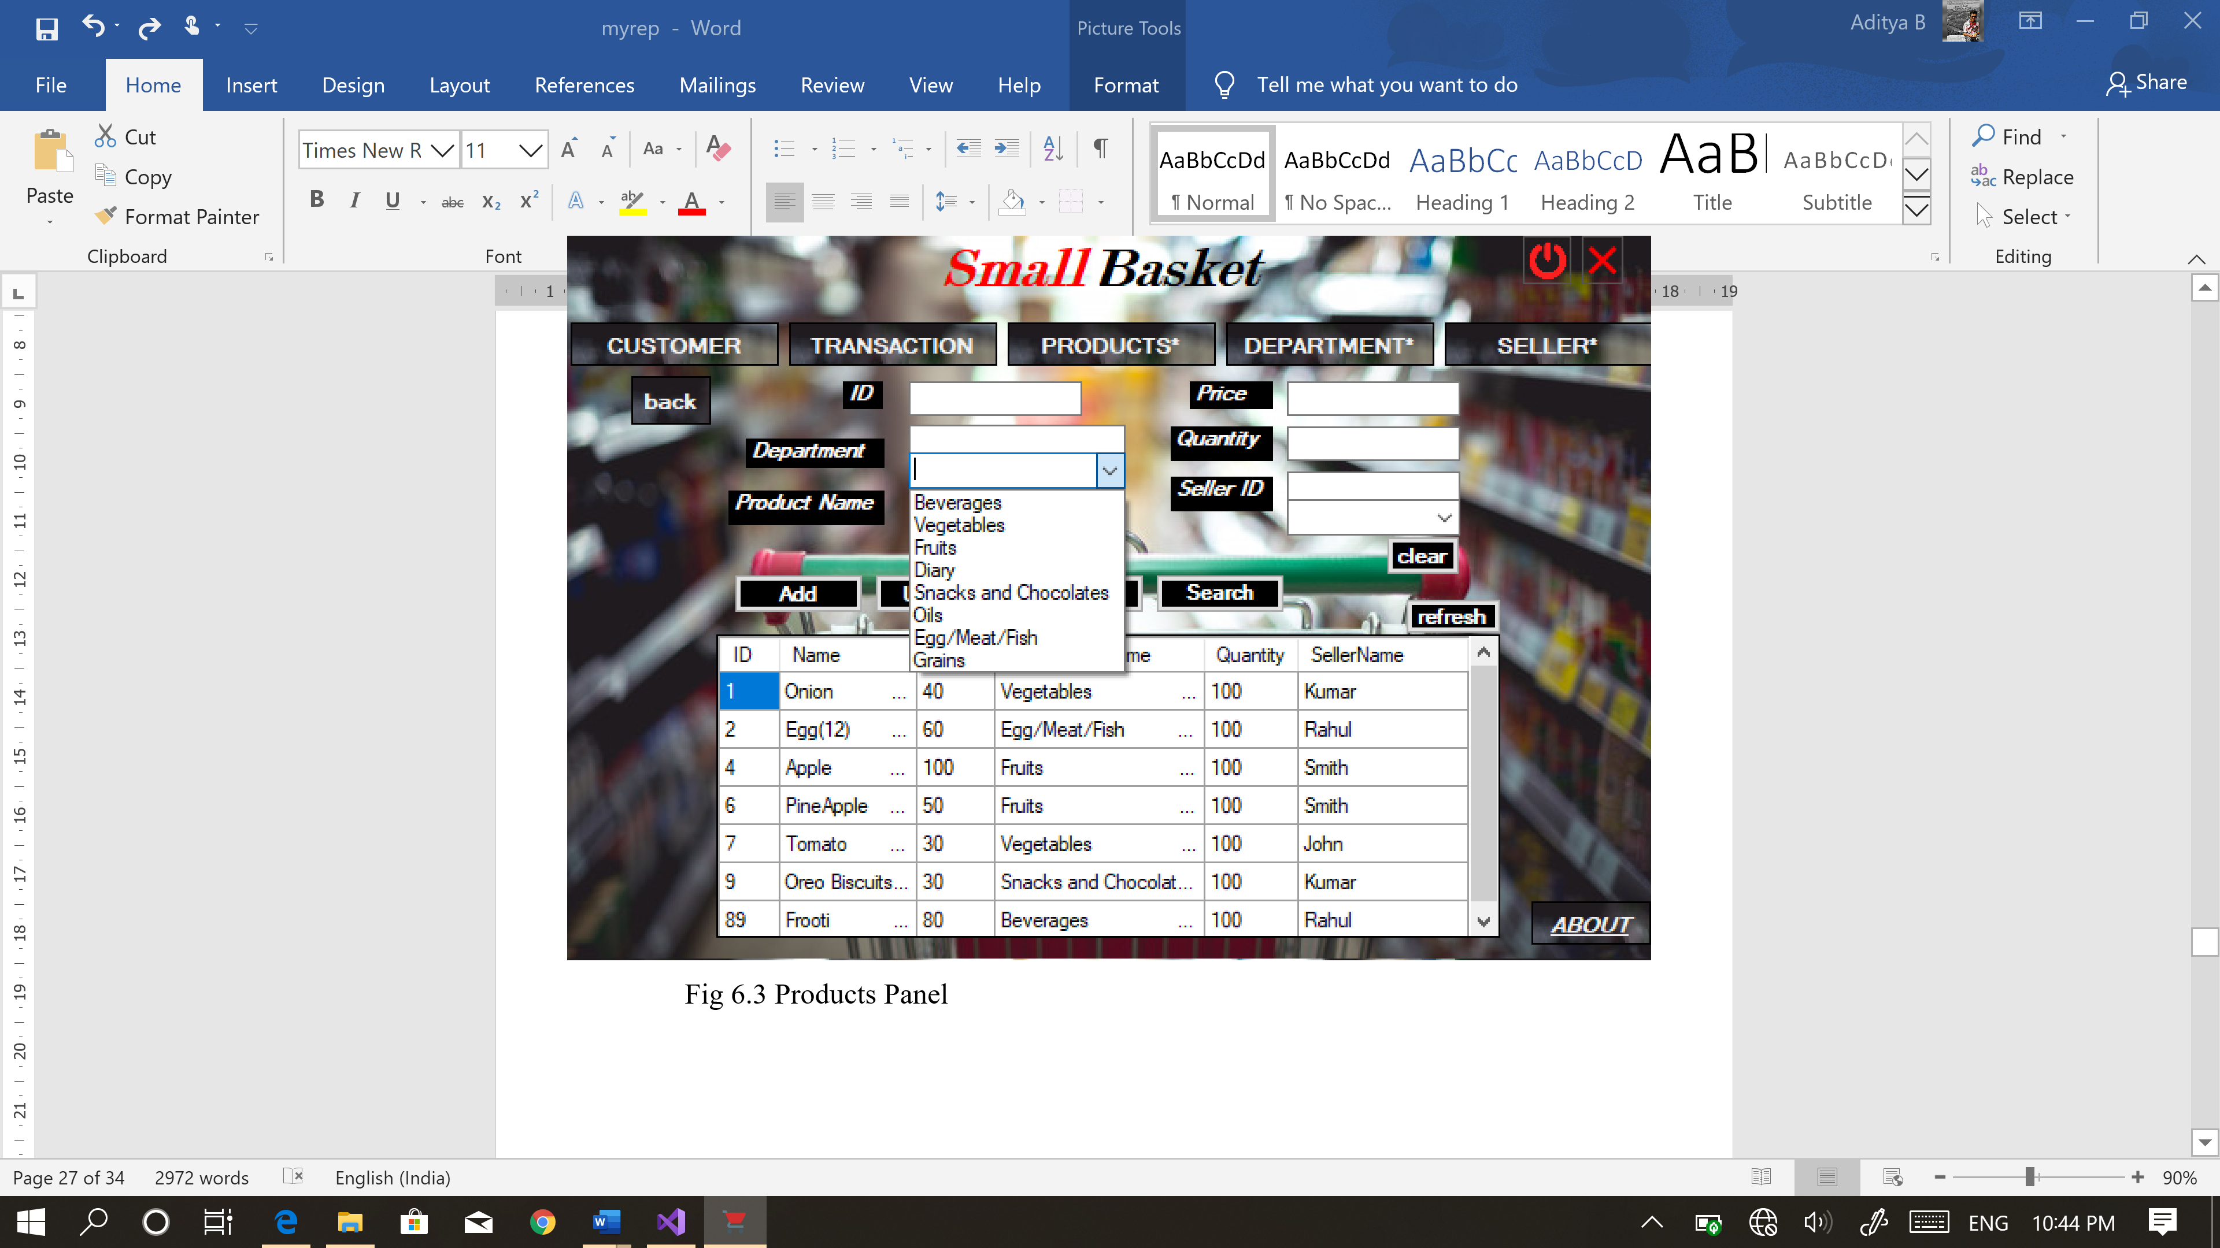

Fig 6.4 **Products Panel**

This panel consists of buttons to do certain tasks on the **Products** Table. It has 6 textboxes to enter value in its respective column of the table. **Add** button is used to insert values into the table. **Update** button used to make changes to the existing values in the table. **Delete** button is to delete the row by its Product number. **Search** button is used to search for a product by its number in the table. The **DataGrid** displays the Products Table.

6.5 **Customer panel:**

It has 6 textboxes to enter value in its respective column of the **Customer** table. **Purchase** button is used to insert values into the Customer table and certain fields in the Transaction table. The **DataGrid** displays the **Customer_log** Table which is auto generated by a **Trigger**.

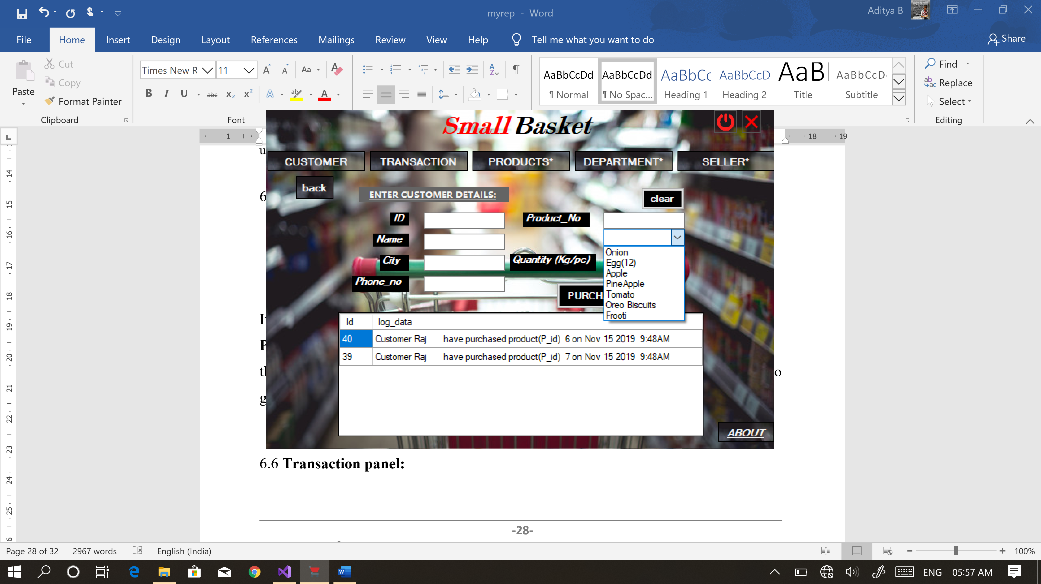

Fig 6.5 **Customer Panel**

6.6 **Transaction panel:**

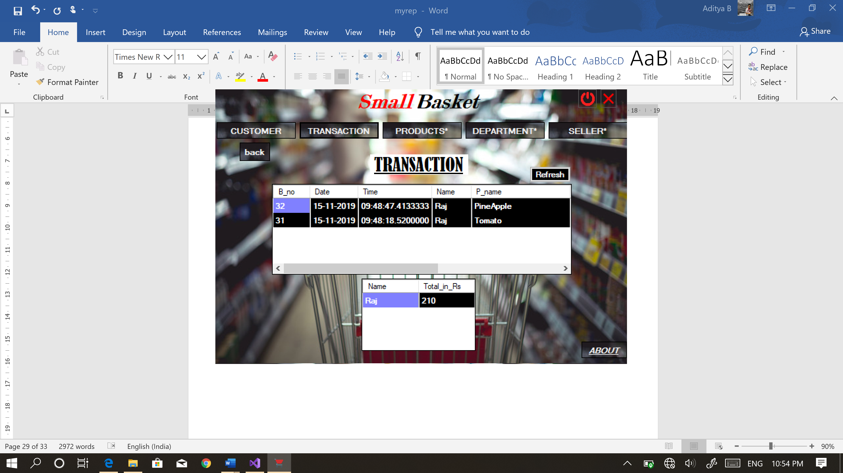

Fig 6.6 **Transaction Panel**

It consists of only 2 **DataGrid** which displays the **transaction** which is made by each **customer** and the **Total** **bill** to be paid by each customer.

**Chapter 7**

**Summary & Recommendations**

7.1 **Summary**

With the theoretical inclination of our syllabus it becomes very essential to take the atmost advantage of any opportunity of gaining practical experience that comes along. The building blocks of this Major Project ”**Grocery Database Management System**” was one of these opportunities. It gave us the requisite practical knowledge to supplement the already taught theoretical concepts thus making us more competent as a computer engineer. The project from a personal point of view also helped us in understanding the following aspects of project development:

• The planning that goes into implementing a project.

• The importance of proper planning and an organized methodology.

• The key element of spirit and confidence in a successful project.

The project also provided us the opportunity of interacting with our teachers and to gain from their best experience

7.2 **Future Recommendation**

**GROCERY DATABASE MANAGEMENT** is a software application to build such a way that it should suits for all type of Grocery Stores in future.

One important future scope is that all the data is well organized in datbase which is very helpful for the store. This will provide availability of products in the store on time. It keeps a record of all customer purchased items, date, time automatically when the bill is generated. The Store will never go wrong with their accounting calculations as everything is software is auto generated once when the customer has purchased an item.

**Chapter 8**

**Conclusion**

This project’s main aim is to reduce the work load on Grocery Stores like maintaining different records for different fields i.e. for customer detail, order and product details is a long hectic and tiresome and time-consuming process. This project can be implemented at any levels of grocery store like More Store, Safal daily frash ,etc..

This project is a multi-purposed software which can store details of Seller, Department, Customer, and their respective orders which is accurate with timing functionality and status procedure which ensures whether the order is placed successfully by the store.

**References**

[1] Database System Model, Languages, Design and Application Programming,

Ramez Elmasri and Shamkant B. Navathe, 7th edition, 2017, Pearson.

[2] Database Management System, Ramkrishnan, and Gehrke, 3rd edition, 2014,

McGrawHill.

[3] www.c-sharpcorner.com

[4] www.studentcompanion.co.in